40 Clusters
No Change
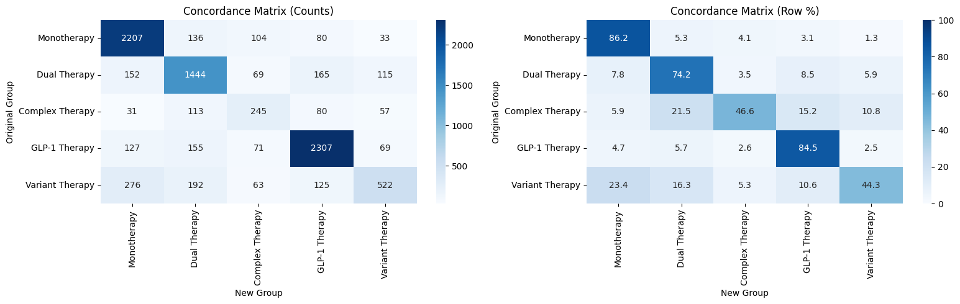
13: ‘Monotherapy’
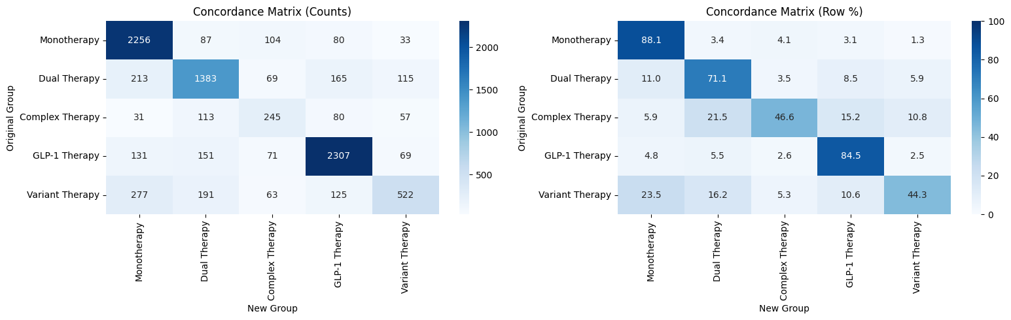
17: ‘Dual Therapy’ - It's just a dual therapy
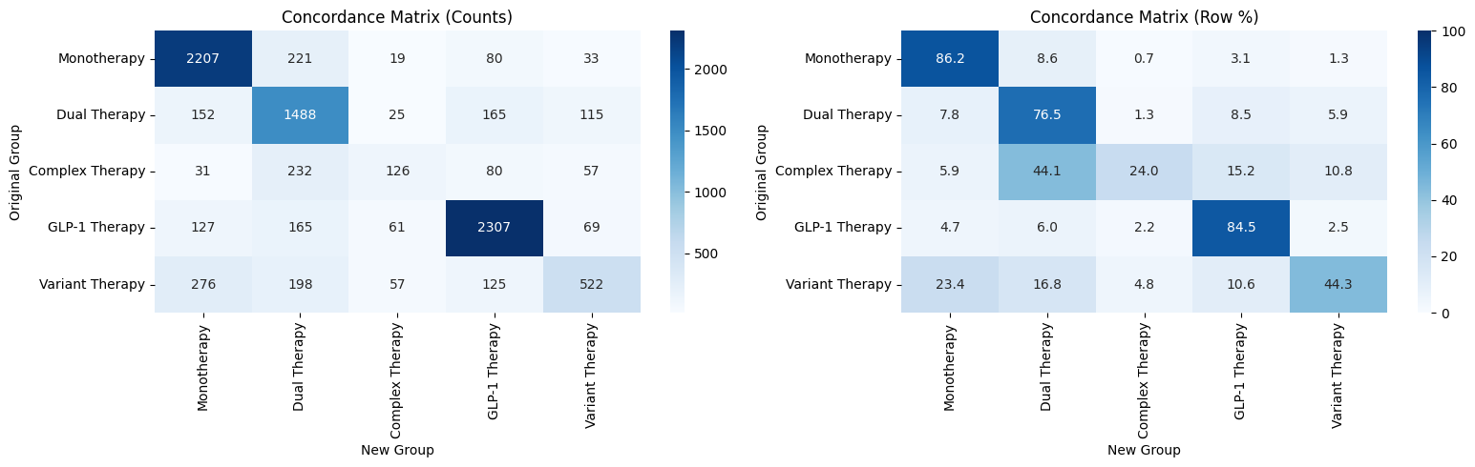

17: Dual Therapy, 30: Complex Therapy - This one is weird because 30 should be complex
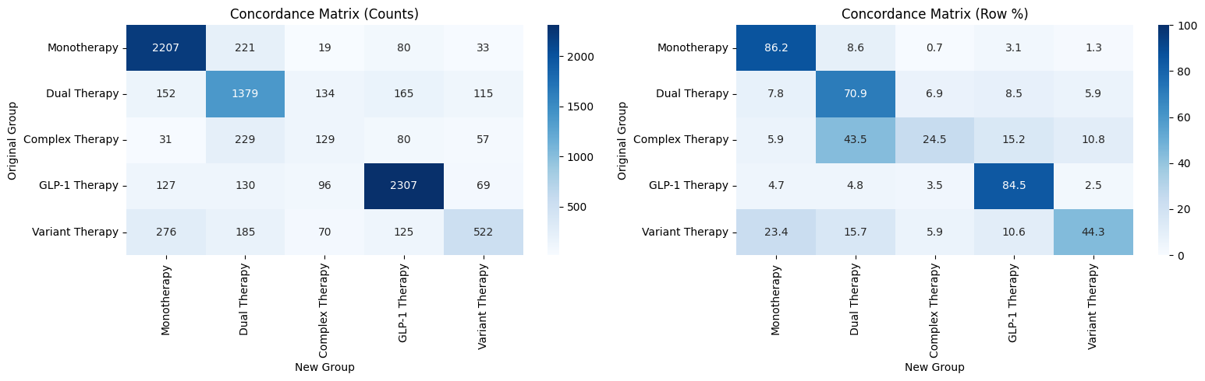
17: Dual Therapy, 31: GLP-1 Therapy - Also difficult since 31 is glp-1 therapy
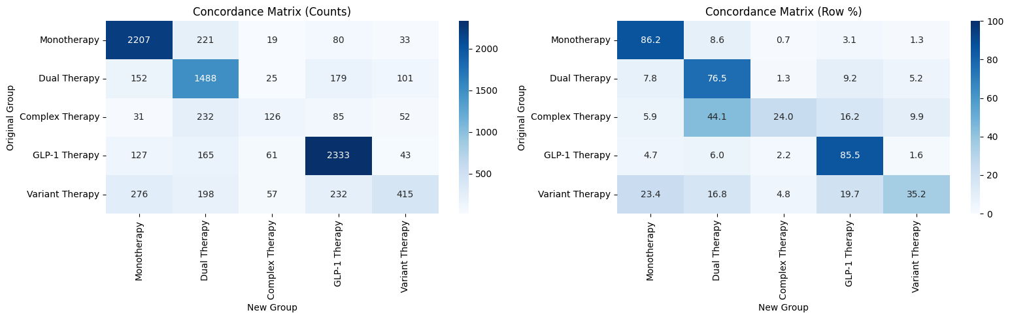
17: Dual Therapy, 31: GLP-1 Therapy, 32: ‘Complex Therapy’
